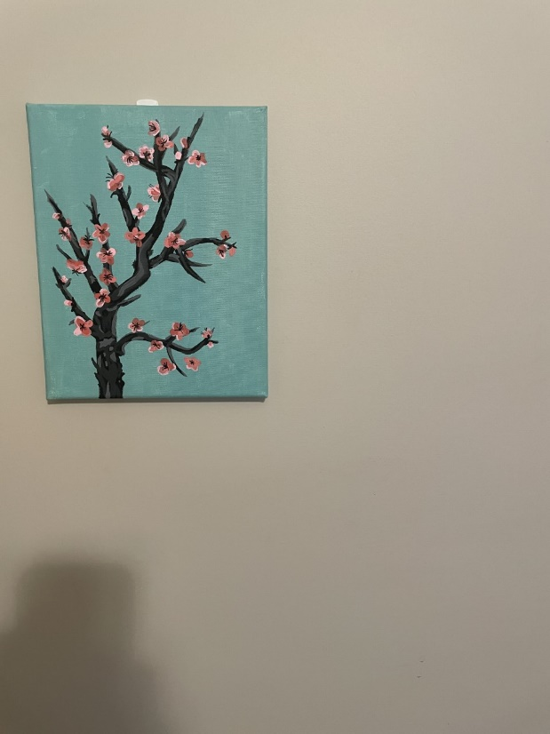This is acrylic paint.

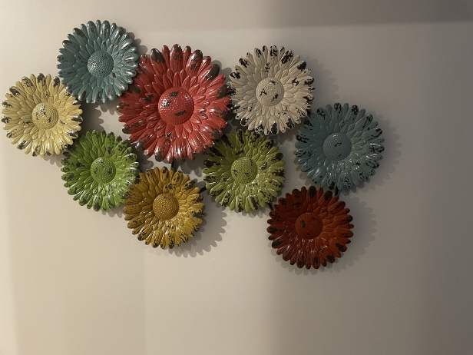This is a sculpture of metal.

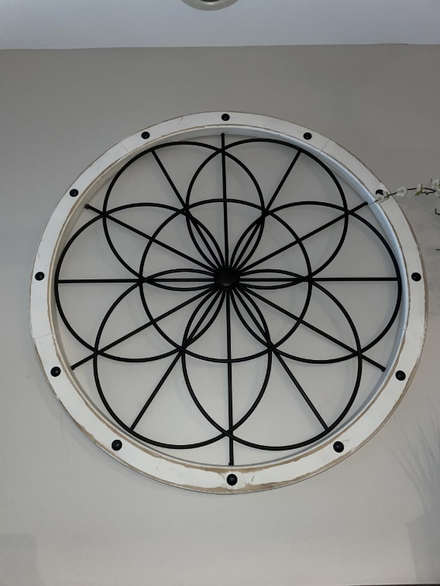This is wood and metal.

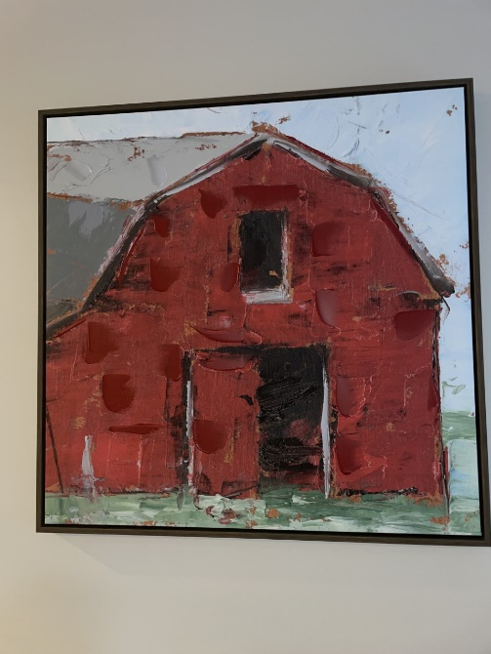This is an oil painting.

This is a wood engraving.